Cleaning and Structuring the Data
- Handle missing values
- Remove duplicate or inconsistent data
- Standardize the data format
Problems:
- User ID 3 has an empty name. (.strip())-> only if the name is NOT empty after trimming spaces.)
- User ID 4 has a duplicate friend entry.
- User ID 5 has no connections or liked pages (inactive user).
- The pages list contains duplicate page IDs.
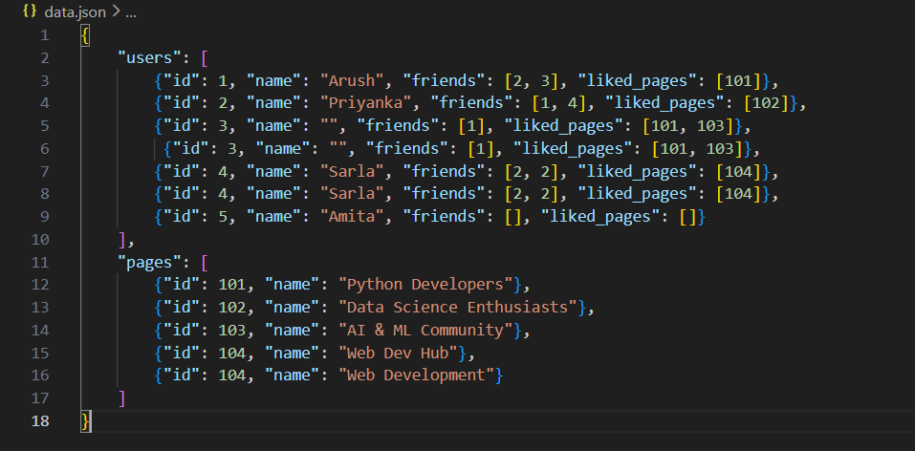
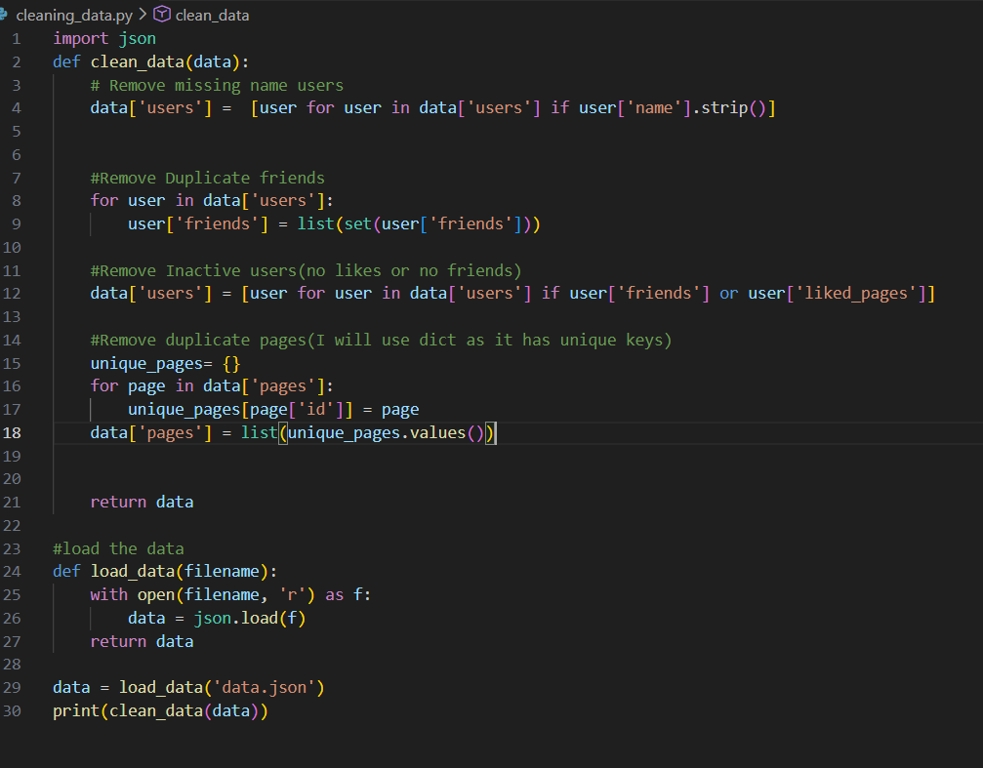

Now I need to generate file into meaningful format for users,
{
'users': [{'id': 1, 'name': 'Arush', 'friends': [2, 3], 'liked_pages': [101]}, {'id': 2, 'name': 'Priyanka', 'friends': [1, 4], 'liked_pages': [102]}, {'id': 4, 'name': 'Sarla', 'friends': [2], 'liked_pages': [104]}, {'id': 4, 'name': 'Sarla', 'friends': [2], 'liked_pages': [104]}],
'pages': [{'id': 101, 'name': 'Python Developers'}, {'id': 102, 'name': 'Data Science Enthusiasts'}, {'id': 103, 'name': 'AI & ML Community'}, {'id': 104, 'name': 'Web Development'}]
}
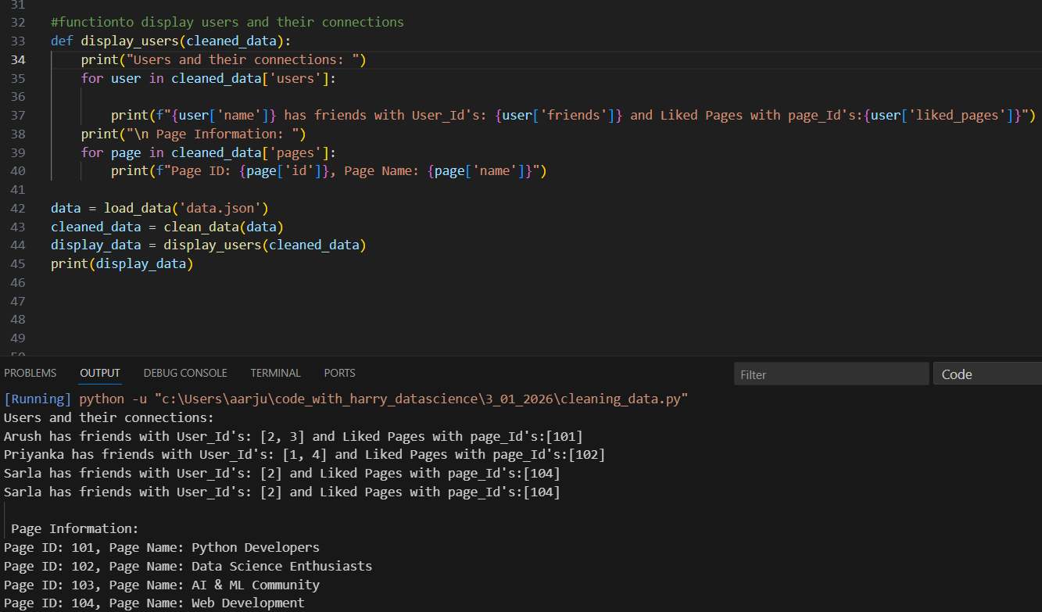
The meaningful insights from JSON after cleaning and processed will save inside my .txt file for user.
